**DSA Assignment – 3rd July**

**Name – Karan Joshi**

**Roll No. – 23/11/EC/036**

**Leetcode Id – Karan_Joshi068048**

**Geeksforgeeks Id – wwwjoshikaran3424**

**Github Repo Link -** [**https://github.com/KaranJoshi101/urban-octo-robot/**](https://github.com/KaranJoshi101/urban-octo-robot/)

DSA-Section -

Question 1: Baseball Game

Platform: LeetCode

Problem Link: <https://leetcode.com/problems/baseball-game/description/>

Submission Screenshot:

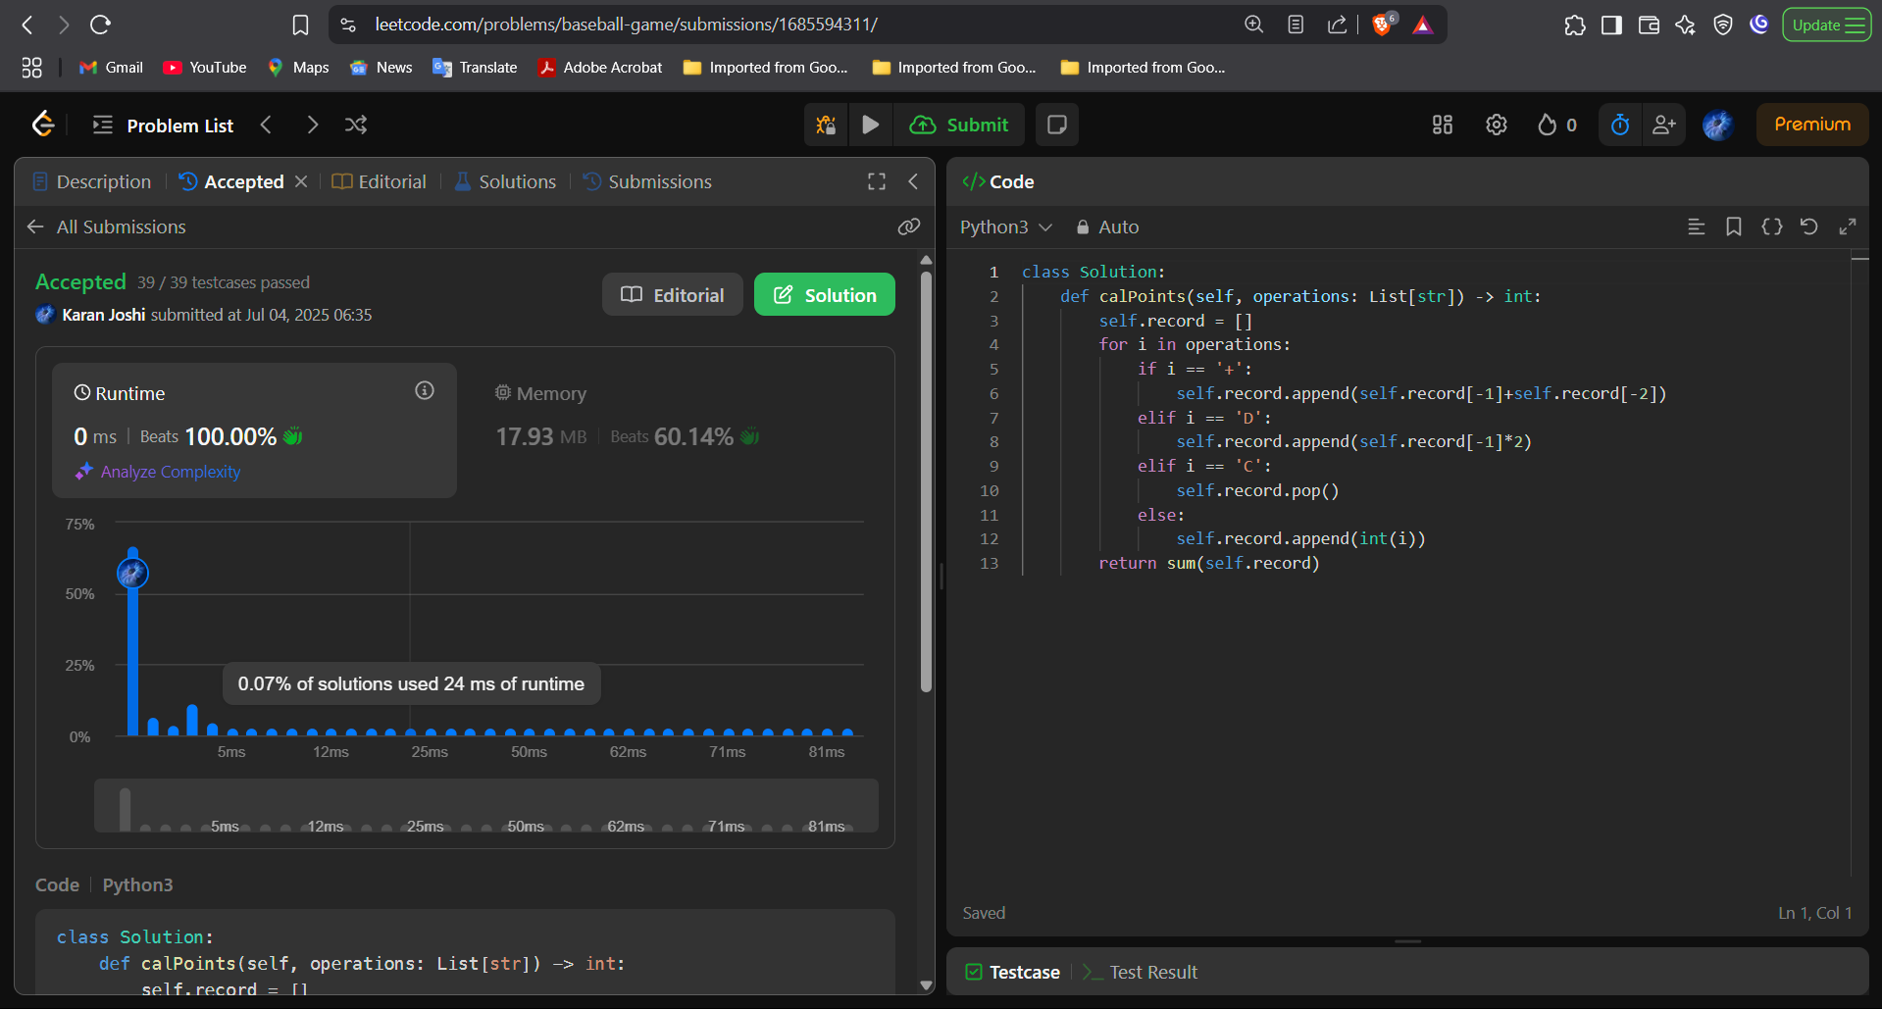

Question 2: Stock Span

Platform: LeetCode

Problem Link: <https://leetcode.com/problems/number-of-atoms/description/>

Submission Screenshot:

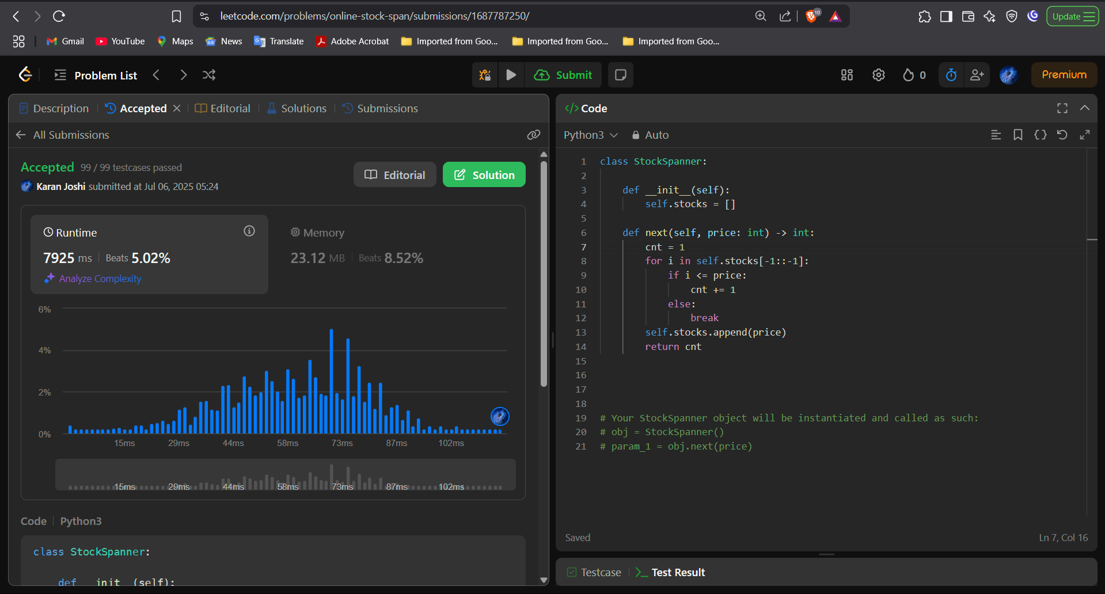

Question 3: Linked List Random Node

Platform: LeetCode

Problem Link: <https://leetcode.com/problems/linked-list-random-node/>

Submission Screenshot:

